Diary Application Introduction

Author name: Jiang Zheyan

Student number:20161657

1. Function
2. Write diary
3. Add video: shoot, open file
4. Add picture: shoot, open file
5. Add music: record, open file
6. Store
7. Read
8. Open calendar
9. View the diary in the calendar panel
10. View the diary in the timeline
11. Check the weather of the day
12. Pages:

I added six pages:

Main Activity

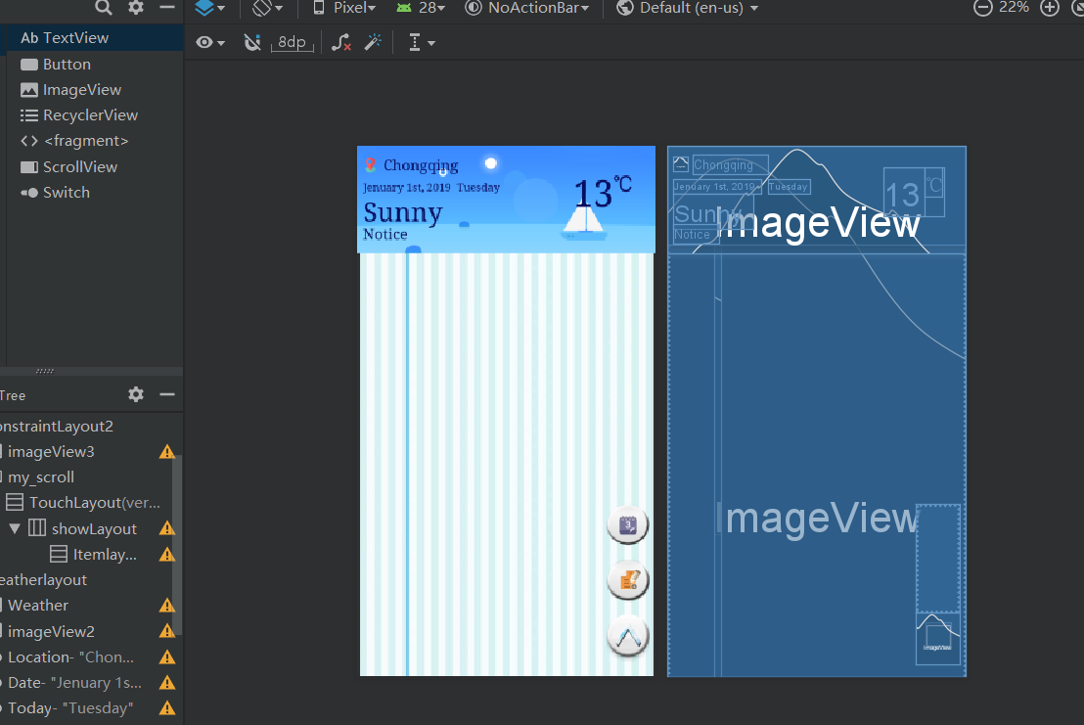

Calendar Activity

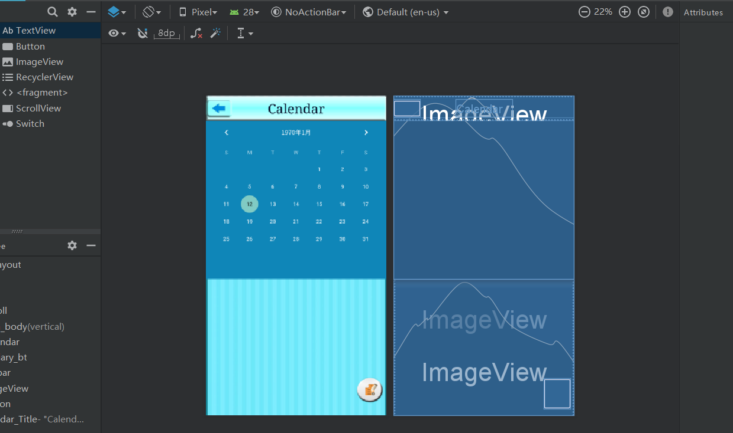

Diary Activity

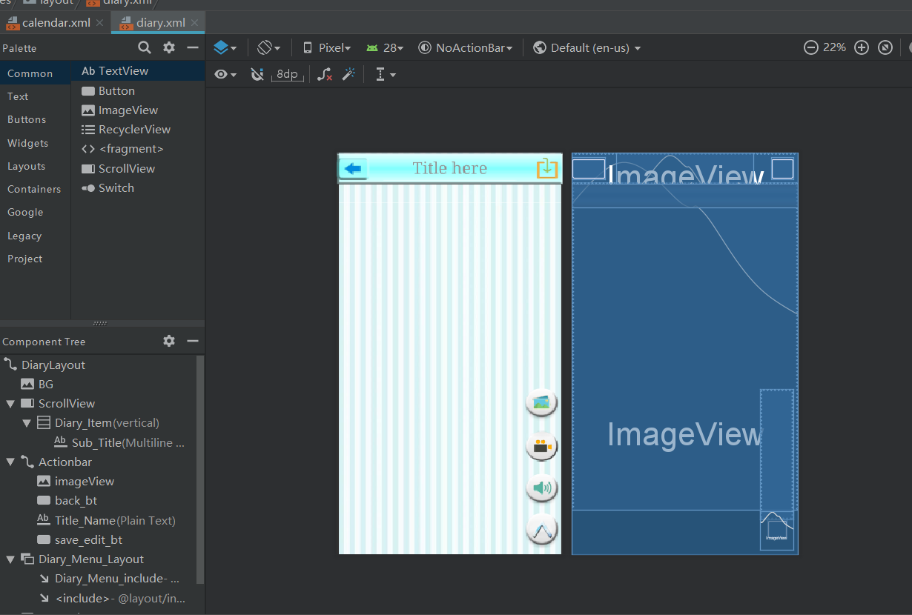

Open picture

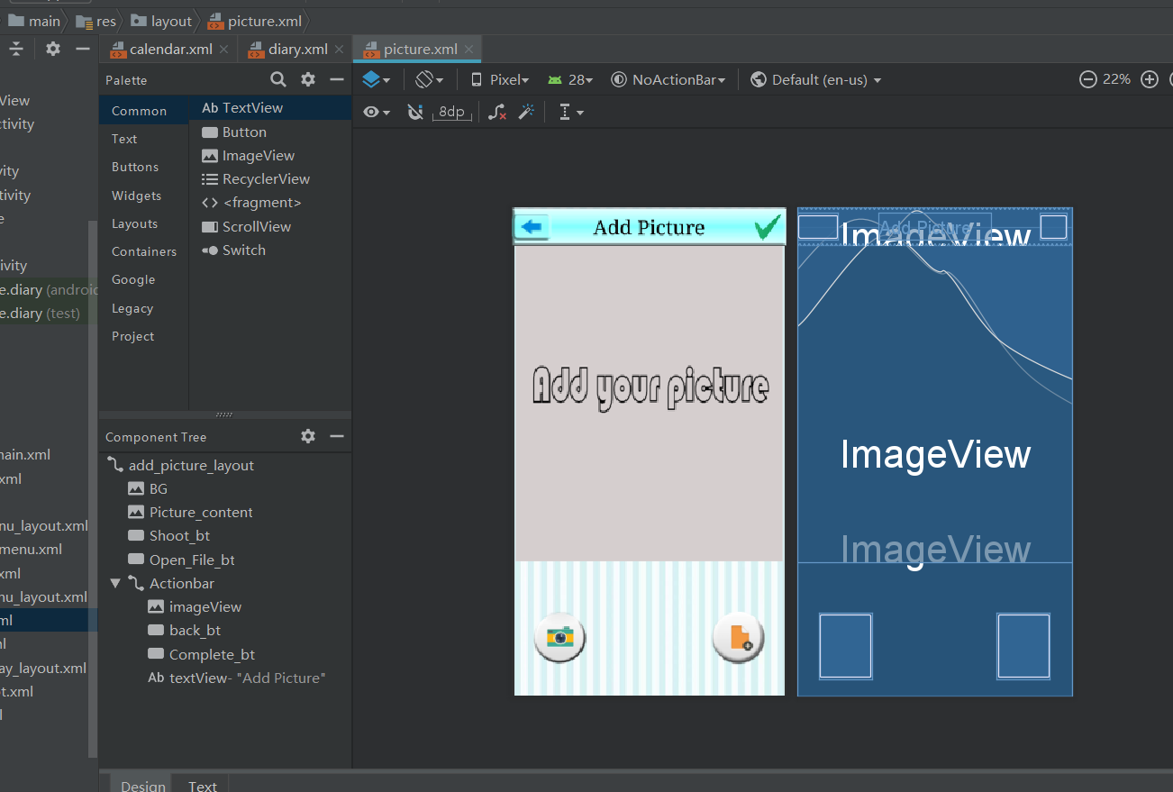

Open video

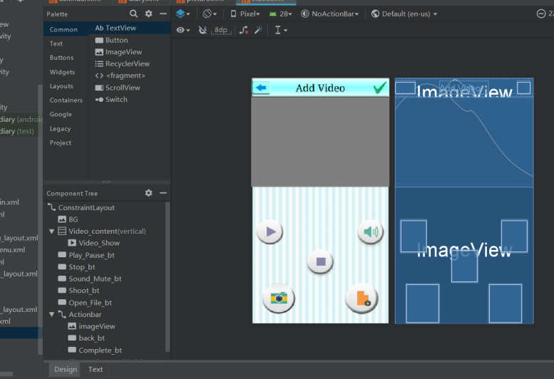

Open sound

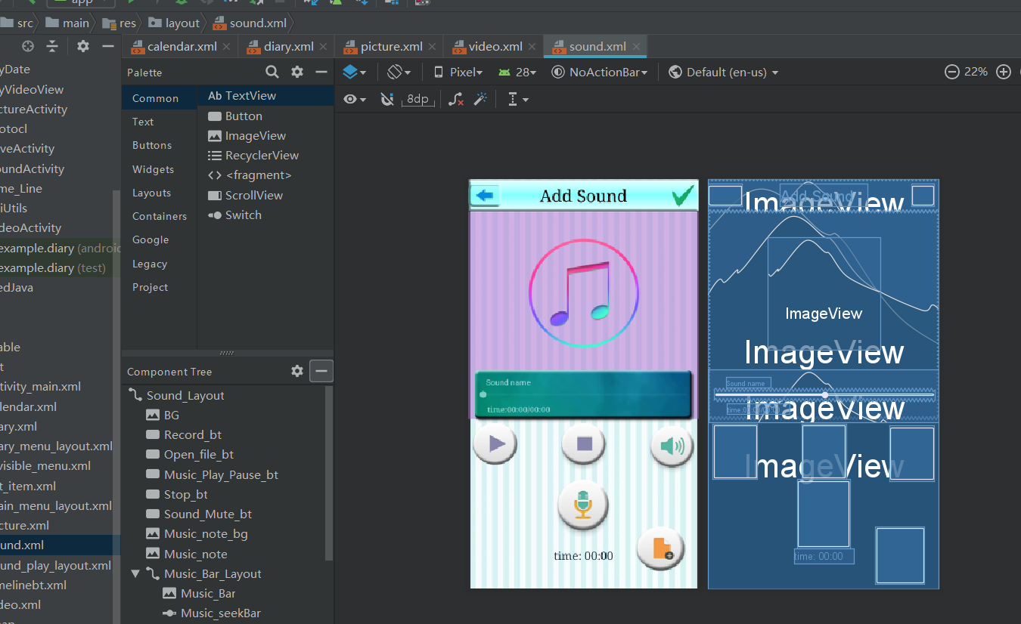

Used two custom controls

Time line item

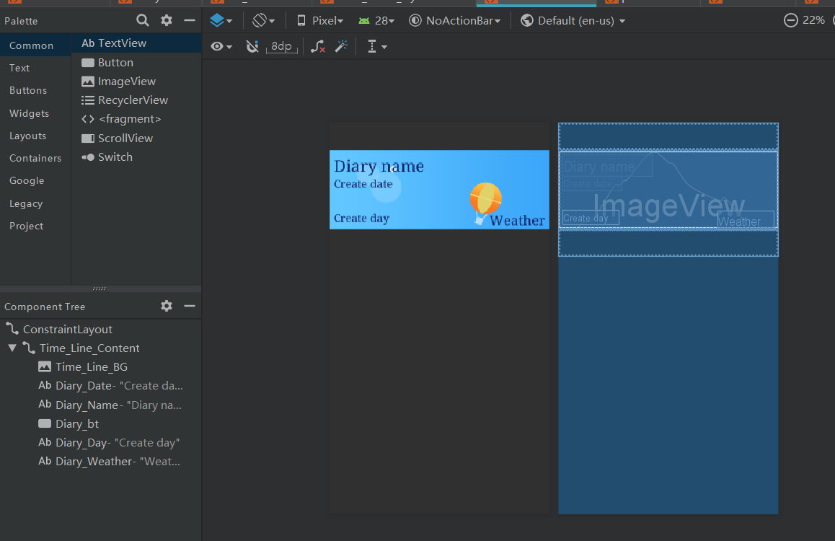

List item

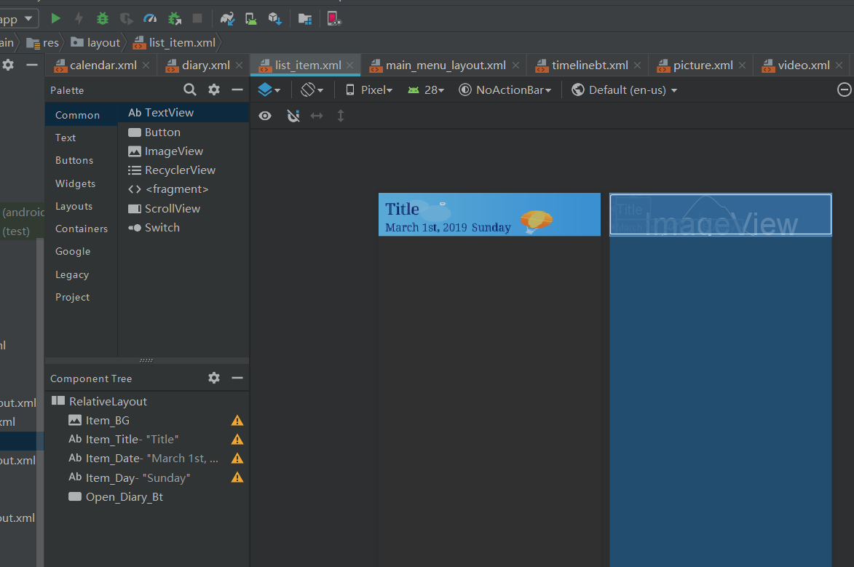

1. Install

Install the apk on the github named “My Diary.apk”

You should allow the following permission:

Read to storage

Write to storage

Camera use permission

Microphone use permission

1. Configuration

If opening the sound is refused, you should open the microphone use permission manually, and then, you do not need any other configuration.

Enjoy your writing